Date:
Team ID:
Project Name: DarshanEase
Empathy Map Canvas
User Persona: Devotee / Temple Visitor
1. Says
"I want to book darshan tickets easily online."
"I don't want to wait in long queues."
"I need information about temple timings and available slots."
2. Thinks
"Will I get a darshan slot on my preferred date?"
"How can I save time during my temple visit?"
"Is my booking confirmed?"
3. Does
Searches online for temple details.
Visits temples and waits in queues.
Tries to find available darshan timings.
Books tickets through available platforms.
4. Feels
Frustrated due to long waiting times.
Confused about booking processes.
Happy when darshan is organized and convenient.
5. Pains (Challenges)
Long queues at temples.
Difficulty finding accurate slot availability.
Manual booking problems.
Time wastage.
6. Gains (Needs)
Easy online darshan booking.
Quick confirmation of tickets.
Information about temple timings and slots.
Smooth and stress-free temple visit.
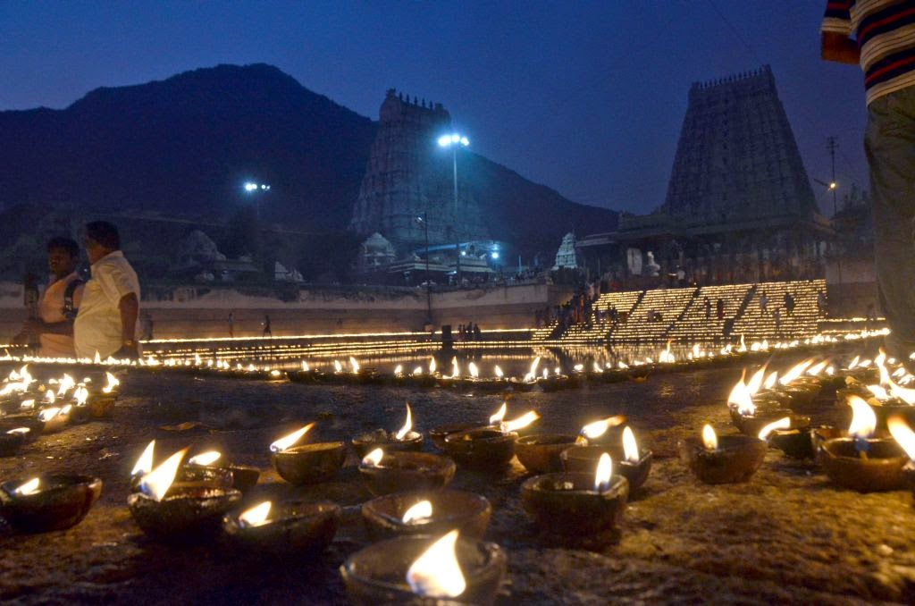
This Photo by Unknown Author is licensed under CC BY

